BAIT Compliance for Log360
Tagline: Meet BaFin's requirements for banks with comprehensive log monitoring from Log360.

Overview
The BAIT (BaFin Supervisory Requirements for IT in Banks) Compliance extension for Log360 helps German credit institutions meet BaFin's requirements for IT governance, access management, IT operations security, and incident management as defined in BAIT.
Log360 collects and correlates log data from banking applications, core systems, cloud platforms, and network infrastructure, providing continuous monitoring of IT security events. Compliance and IT security teams can track user access, detect anomalies, and generate the audit-ready evidence required for BaFin inspections and internal IT audits.

Key Features
- Generate predefined BAIT compliance reports covering IT operations security, identity and access management, and security incident monitoring.
- Track privileged user activities, system configuration changes, and access to critical banking applications in real time.
- Continuously correlate security events across your IT environment to detect suspicious activity and policy violations aligned with BAIT incident detection and response obligations.
- Export audit evidence in PDF and CSV formats for BaFin supervisory examinations and internal IT risk committee reviews.



Screenshots
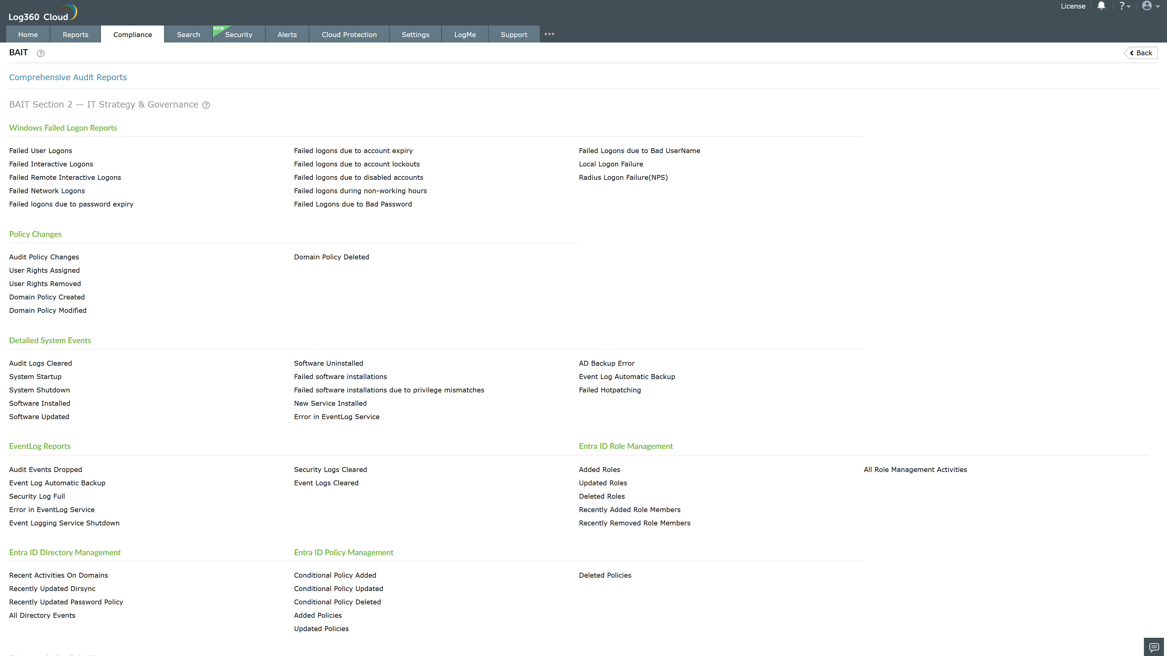
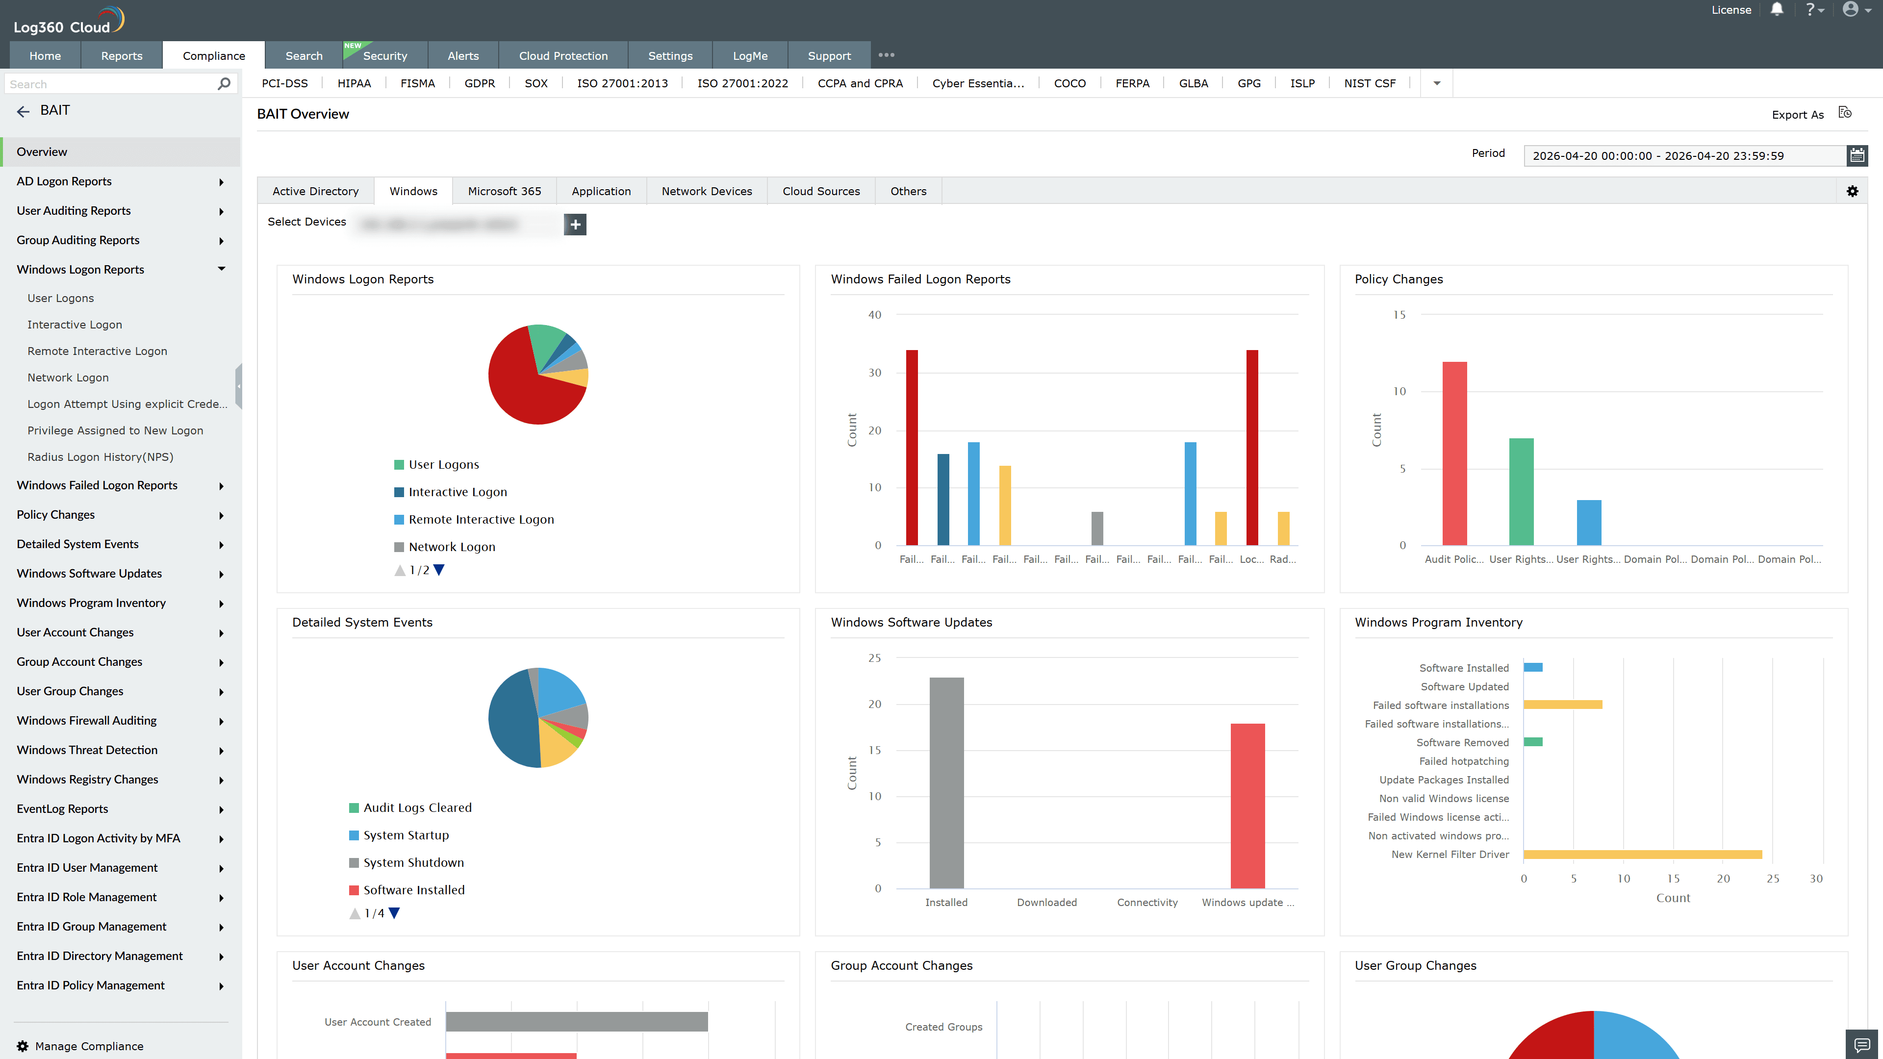
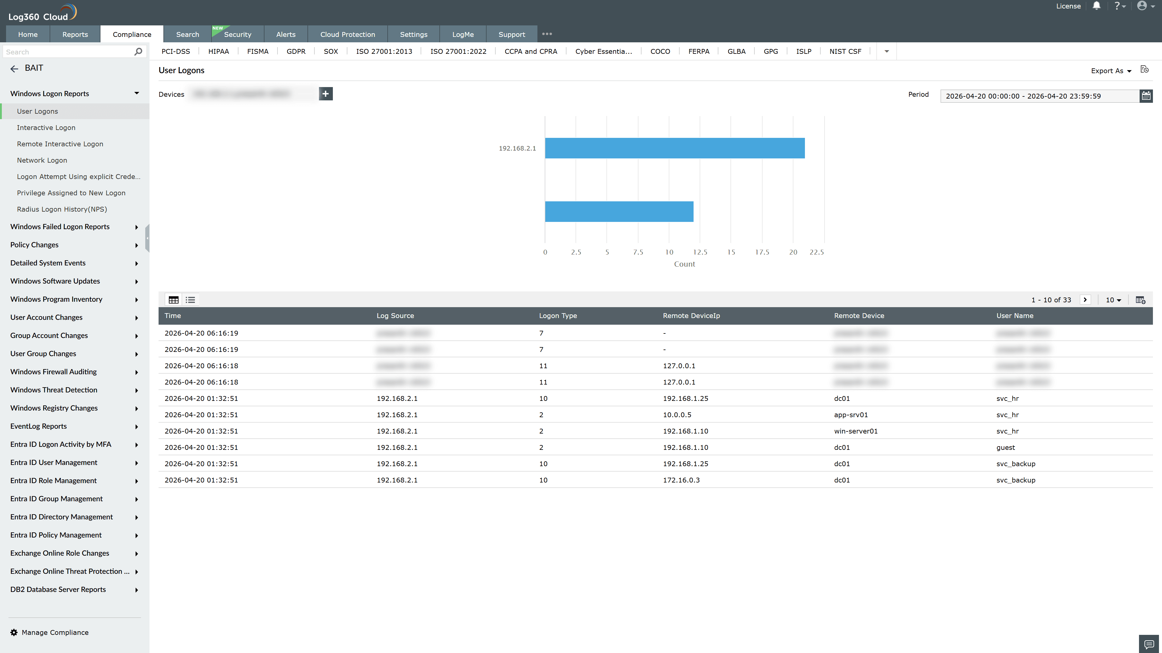
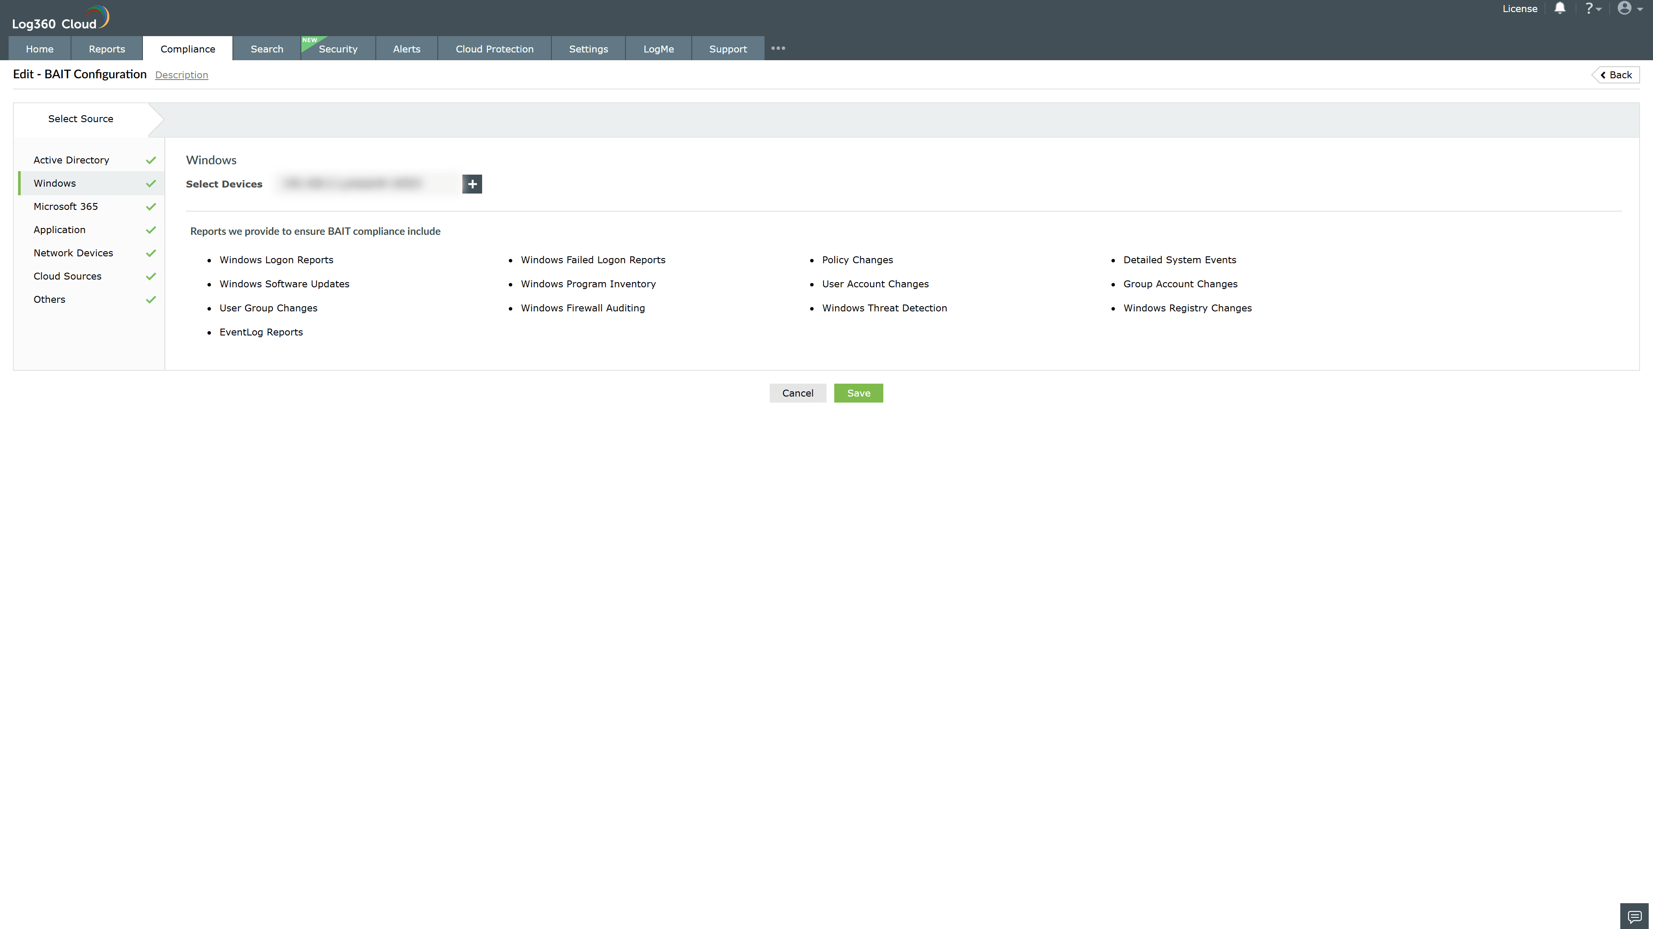

Valid Submission : Yes
Supported Editions : Free, Basic, Standard, Professional, MSSP
Help Document : https://www.manageengine.com/log-management/help/integrations/compliance-extensions.html
Help Video : Not provided
Tags : Log360, Compliance, Privacy monitoring, Data privacy, Regulatory compliance
Supported DCs : US, IN, JP, CA, AU, UK and EU
Privacy Policy:
Terms of Service:
Release Notes:
Predefined reports for the BAIT compliance

